**🔹 Phase 1: Branding & Business Setup**

**📌 Task:**

1. **Brainstorm and create a business name, tagline, and brand mission.**
2. **Use ChatGPT to generate a compelling brand story that highlights AI-driven branding.**
3. **Use Canva Magic Media to create a unique AI-generated logo.**

**💡 Vibe Coding Prompts for Phase 1: ✏️ ChatGPT Prompt: *"Imagine you're creating a futuristic digital branding agency powered by AI. Generate a business name, tagline, and a compelling brand story that appeals to startups."***

**🎨 Canva Magic Media Prompt: *"Create an AI-generated logo for a modern digital branding agency. The theme should be sleek, futuristic, and tech-driven."***

**🔹 Business Name:**

**NeuroBrand**

**🔹 Tagline:**

**“Intelligence that Inspires Brands.”**

**🔹 Brand Story:**

In the ever-evolving world of digital entrepreneurship, speed and creativity are everything. **NeuroBrand** was born at the intersection of artificial intelligence and design thinking — a next-gen branding agency that empowers startups to launch with confidence, clarity, and cutting-edge visuals.

We believe that every startup has a story worth telling — and telling it well should be effortless. Our AI-driven platform decodes your vision, understands your market, and transforms abstract ideas into captivating brand assets: logos, taglines, color palettes, social content, and beyond.

Gone are the days of hiring expensive agencies or waiting weeks for a logo. With NeuroBrand, your brand evolves as fast as your business does — adaptive, intelligent, and uniquely yours.

Whether you're a solo founder with a bold idea or a growing startup ready to scale, **NeuroBrand** is your creative partner — blending data with design to build brands that break through the noise.

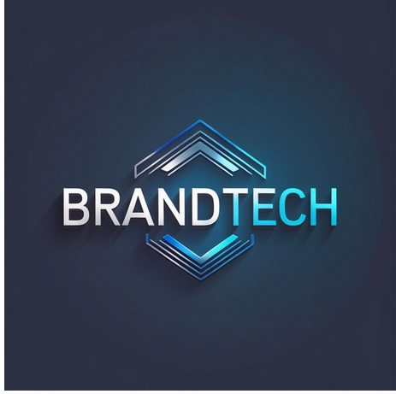

**🔹 Phase 2: AI-Generated Design & Marketing Content**

📌 **Task:**

1. **Social Media Content:** Generate AI-enhanced posts and graphics.
2. **Website Mockups:** Use Canva to design sample website layouts.
3. **Marketing Copy:** Use ChatGPT to write engaging ads, blog posts, and product descriptions.

💡 **Vibe Coding Prompts for Phase 2:** 📢 **Social Media AI Prompt (ChatGPT):** *"Generate five engaging social media post ideas that promote AI-powered branding services. Each post should have a call to action."*

🖼️ **Canva Magic Media Prompt:** *"Generate an AI image of a vibrant social media post showcasing the power of AI branding for businesses."*

📑 **Marketing Copy Prompt (ChatGPT):** *"Write an AI-generated blog post explaining why businesses should use AI-powered branding services to stay competitive."*

**📢 Social Media AI Prompt (ChatGPT):**

**Five Engaging Social Media Post Ideas for NeuroBrand**

Each with a **call to action (CTA)**:

**1. Post Title:** *Your Brand Deserves a Brain*  
**Caption:**  
Why settle for generic when your brand can be *genius*?  
At NeuroBrand, we use AI to craft logos, taglines, and strategies that speak to your audience — instantly.  
✨ Smarter branding starts here.  
👉 **DM us for a free brand audit!**

**2. Post Title:** *Turn Ideas into Impact – Instantly*  
**Caption:**  
Have an idea? Let AI do the creative heavy lifting.  
NeuroBrand turns your concepts into stunning visuals and sharp messaging – all powered by intelligent design.  
💡 AI is your creative partner now.  
🔥 **Book a demo today!**

**3. Post Title:** *Build a Brand in 24 Hours – Literally*  
**Caption:**  
From idea to identity in a single day.  
NeuroBrand's AI engine creates logos, colors, and content at record speed so you can *launch faster*.  
🚀 Don’t wait for perfection. Start with precision.  
🔗 **Start building your brand now!**

**4. Post Title:** *Ditch the Guesswork. Embrace AI Creativity.*  
**Caption:**  
Stop overthinking fonts, colors, and slogans.  
With NeuroBrand’s AI, your branding decisions are *data-backed and design-approved*.  
🎯 Branding has never been this efficient.  
📥 **Sign up for your free AI brand starter kit!**

**5. Post Title:** *The Future of Branding is Now*  
**Caption:**  
AI is changing the branding game.  
Smart logos, optimized messaging, and viral content — all at your fingertips.  
🧠 NeuroBrand helps startups compete like giants.  
💬 **Comment “AI” to get started!**

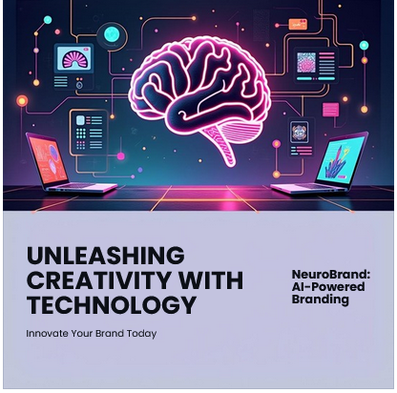

**📑 Marketing Copy Prompt (ChatGPT):**

**AI-Generated Blog Post**

**Title:** *Why Your Business Needs AI-Powered Branding to Stay Competitive*

**In today’s hyper-digital world, first impressions aren’t just important — they’re everything.** And when it comes to standing out in a crowded marketplace, your brand is your loudest voice. That’s where **AI-powered branding** changes the game.

Gone are the days when creating a strong brand meant hiring costly agencies or waiting weeks for results. Today’s startups and small businesses can leverage the speed, precision, and creativity of artificial intelligence to build beautiful, strategic, and *data-informed* brands in a fraction of the time.

At **NeuroBrand**, our AI doesn’t just generate logos or color palettes — it understands your audience, analyzes trends, and delivers assets that *resonate*. Whether you're launching a new business or refreshing an old identity, AI ensures your branding is aligned with today’s market realities.

From social media graphics to persuasive messaging, AI empowers entrepreneurs to:

* Launch faster with intelligent design tools
* Save thousands in branding costs
* Make smarter, insight-driven decisions
* Continuously evolve as markets shift

**The result?** A brand that connects — emotionally, visually, and digitally.

🚀 Ready to build your future-proof brand with AI?  
📞 [Contact NeuroBrand today] and experience the future of branding.

**🔹 Phase 3: Client Outreach & Monetization**

📌 **Task:**

1. Develop strategies for selling branding assets to clients.
2. Use ChatGPT to craft compelling sales pitches and outreach emails.
3. Design a Canva pitch deck to attract clients for your AI-powered branding service.

💡 **Vibe Coding Prompts for Phase 3:** 💰 **Sales Pitch Prompt (ChatGPT):** *"Write a persuasive email to a potential client explaining how AI-generated branding can help elevate their business presence."*

🤝 **Canva Presentation Prompt:** *"Design a clean and compelling presentation slide that highlights the advantages of AI-generated branding for startups and small businesses."*

**Sales Pitch Prompt (ChatGPT):**

**✉️ Persuasive Outreach Email to a Potential Client**

**Subject:** Elevate Your Brand with AI-Powered Creativity 🚀

**Hi [Client’s Name],**

I hope this message finds you well!

I'm reaching out to introduce **NeuroBrand**, a next-gen digital branding agency that harnesses the power of **AI** to deliver bold, intelligent, and market-ready branding — faster and more affordably than traditional methods.

We specialize in:

* ✅ AI-generated logos, brand colors, and social media graphics
* ✅ Smart copywriting for web, ads, and blog content
* ✅ Branding strategies tailored to your audience using real-time insights

With AI, we’re not just designing — we’re **predicting** what works.

Startups and small businesses like yours benefit by:

* Launching their brands up to **3x faster**
* Saving over **70% in creative costs**
* Getting designs that **actually convert**

I'd love to offer you a **free branding audit** or show you a sample kit tailored to your business.

Let’s schedule a quick call this week — how does [insert 2 time options] sound?

Looking forward to helping your brand stand out,  
Warm regards,  
**[Your Name]**  
Founder, **NeuroBrand**  
📩 [your email] | 🌐 [your website] | 📱 [social handle]

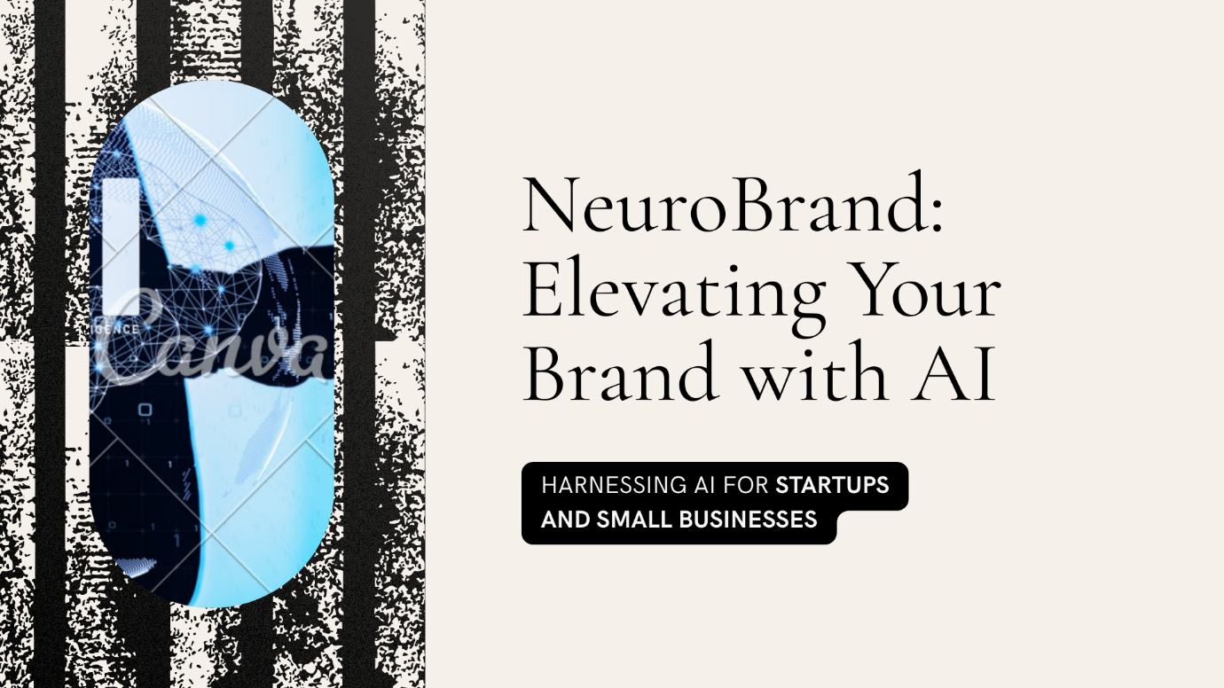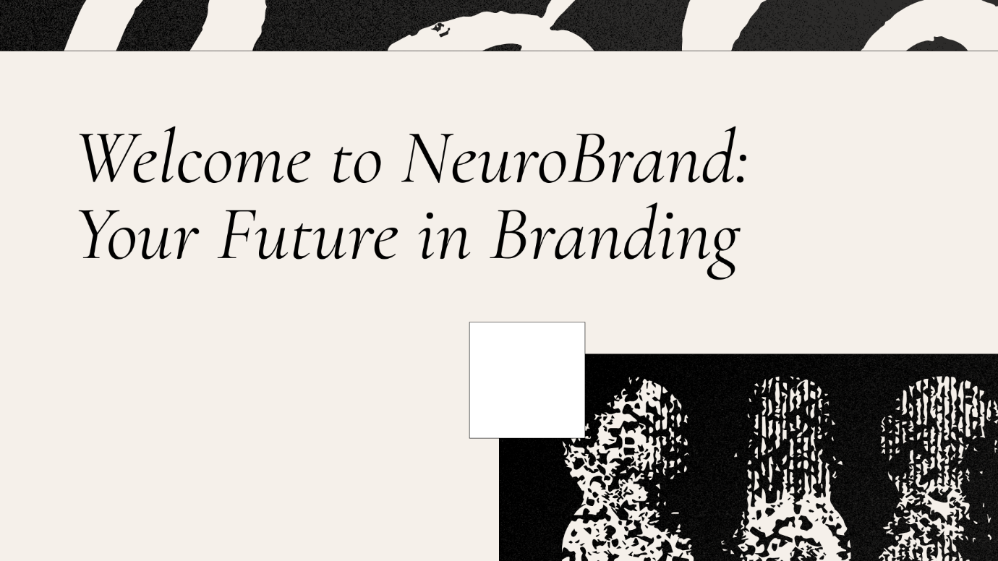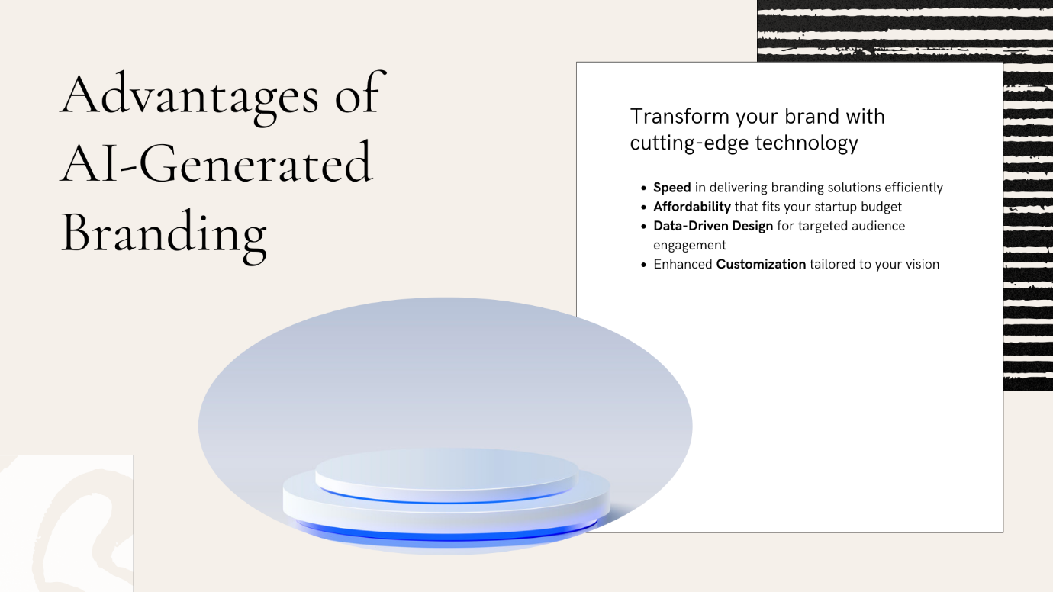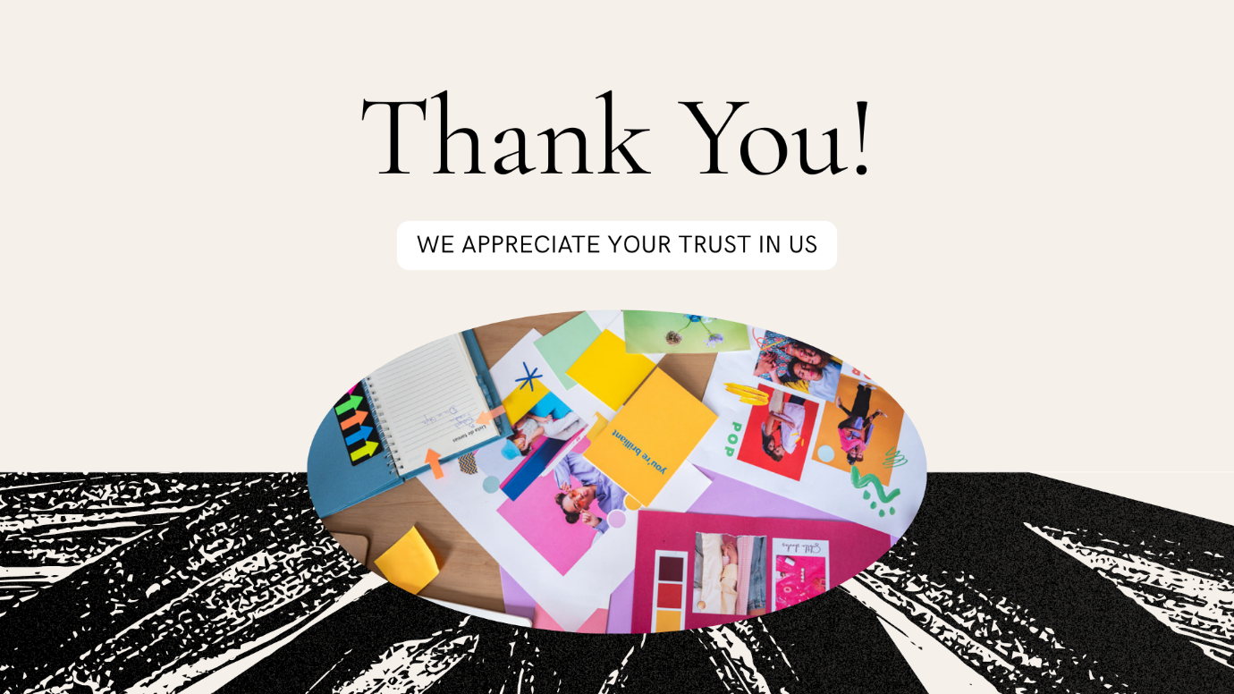

**🧠 NeuroBrand – AI Branding Pitch Deck Structure:**

1. **Title Slide** – Logo + Tagline (“Smarter Branding Starts Here”)
2. **Problem** – Why traditional branding is slow and expensive
3. **Solution** – How AI-powered design solves that
4. **Our Services** – Logos, websites, social media, copywriting
5. **Why AI?** – Speed, affordability, precision
6. **Success Stories** – Testimonials or case studies
7. **Pricing Tiers** – Starter / Pro / Enterprise
8. **CTA Slide** – "Let’s Build Your Brand in 24 Hours"